GlobKart Inventory Management System

Made by- Tested and Supervised by-
Kartikeya Misra Abhay Pratap Singh
B.Tech 2nd Yr(IT) Senior Developer
IET Lucknow. Globtier Infotech Pvt Ltd.
kartikeya.96.misra@gmail.com Noida,UP,India
Summer Training Project
@Globtier Infotech Pvt Ltd
Abstract

This paper describes the GlobKart Inventory Management System,s ability to sufficiently determine the feasibility and usability of all items in an Office in any Organization. The core concept is to track the allotment and allocation of items and office utilities with additional features for interpreting the data. It uses a MVC(Model View Controller) model with a connected database to allow multiple functionalities to be offered to the tool user. This allows for later expansion while still supporting the targeted small businesses. The core features and final framework should be completed within 2 weeks, leaving 2 weeks to implement additional features and testing.

1. Operational Concepts

The GlobKart Inventory Management System is a real-time inventory database capable of connecting multiple item related operations in accordance with their memberwise distribution. This can be used to track the inventory of a small startup bench, or to manage the distribution of items of Office in larger franchise. However, the system merely record data and provides reports of items allocation ,Active office members and their vendor records. The goal is to reduce the strain of tracking rather than to handle all store maintenance. Further features may include the ability to generate reports of different varieties, but again the interpretation is left to the management. In addition, since theft does occasionally occur, the system provides solutions for confirming the store inventory and for correcting item related information.

2. System Requirements

The GlobKart Inventory Management System uses a web-based interface to display inventory data to the user. The product will use of open-source software primarily due to cost of implementation. A PHP (Hypertext Preprocessor) servlet will be hosted by an Xampp Apache web server (on top of any choice of operating system). The first feature of the Item Manager web interface component allows (user) Client to view the current stock of items, along with the capabilities of searching and sorting the items according to their category and members according to their Departments. The second feature of the GKIMS web interface will allow the user to modify item settings such as the status ,their allocation etc. The third feature of this tool is to manage office employees and emolyers according to their designations in office and their departments.

Since a web interface will be used, a network that supports the HTTP/HTTPS protocol must exist, whether it is a private network for an isolated customer deployment or an Internet connection for a multi-site customer deployment. The bandwidth of the network depends on the frequency of usage of the tool. A bandwidth of at least 4 Mbps is recommended (small commercial deployment). The database to store the inventory data will use a MySQL database.

Alternatively, commercially licensed products are available. In particular, the CI(Code Ignitor)PHP framework can be used. This requires a Localhost or a php web server and a Microsoft SQL Server database, which can be implemented on any operating system. However, these alternative system configuration will increase the overall ease for both implementation and deployment.

3. System and Software Architecture

The programming language for the GlobKart Inventory Management System application will be in PHP since the PHP/apache(xampp) architecture will be used. For some instances Javascript,JQuery etc. are also used to enhance functionalities. For Styling purposes mainly Jquery and Bootstrap Libraries are included and used alog with a little use of AJAX and Javascript for Client End Process Dealing.The Main Server end or backend Preocess Handling is completely done through PHP.
Furthermore, the PHP Database Connectivity will use the MySQL driver provided by Xampp for the server to communicate to the inventory database. Upon receiving requests from the clients, the server will issue details to the MySQL database.

MVC DESIGN

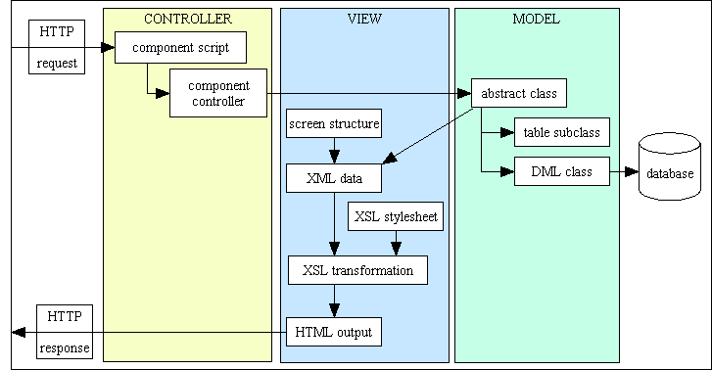
4. DATABASE Relational Schema

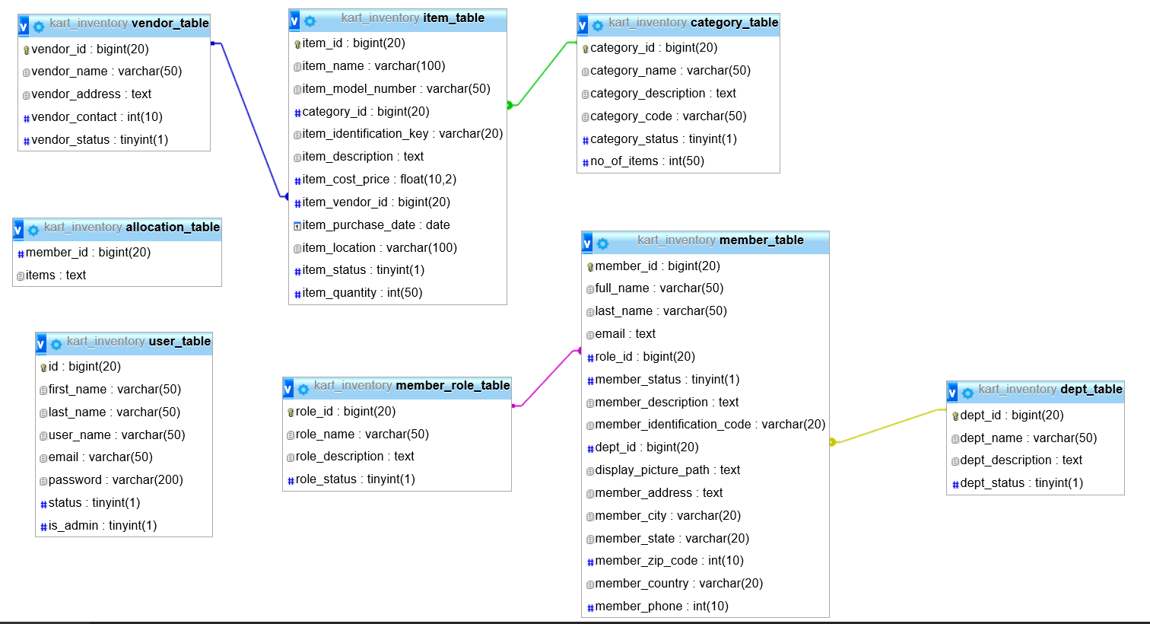

5. Lifecycle Plan

5.1 Objectives

The main goal of GlobKart Inventory Management System is to ensure consistent availability of items for office use and their maintainence. Thus, GlobKart Inventory Management System is directed toward owners of small to large organization managers who are responsible of maintaining sufficient goods on hand in business. It can scale from a single computer running both client and server software up to multiple users.

5.2 Schedules

The time estimated to complete the GlobKart Inventory Management System project is fairly short. There will be three major Win-Win Spiral Model cycles through our prototyping stage, beta release, and final release. We will need two weeks of designing the architecture and implementing core features and two weeks of adding functionality and testing. The project has been completed by developer in at most 4 to 5 weeks.

6. Feasibility Rationale

6.1 Assumptions

The above design should work for the GlobKart Inventory Management System application. A more realistic and upgraded inventory management interface can be done to suit the integration, as the interface does not interfere with the data collected. We expect that the clients are able to update their data to the current point of stock in case of loss of connection to the server. The particular restocking procedure adopted by each store does interfere with the feasibility and accuracy of the application as it does not remind the inventory manager to update the data each time they had done any restocking. We also trust that that the Secure Socket Layer (SSL) is reliable in creating a secure connection between a client and a server.

6.2 Risks

One of the major risks covered by this application is theft breaks synchronization between the inventory and the database. The information could be generated by the data stored in this application. The confidence level of trusting data generated depends on the accuracy of the restocking procedure. Therefore, we are facing a risk of reckless stock manager who could detriment the accuracy of the data. As of the reliability of the SSL encryption, a resolution for this could be by developing SSL and digital certificate policy and configuration guidelines. In addition, giving a choice to the user to set the minimum level of SSL used by not violating the policy should convince them the trustworthiness of the application.
Another risk is the competition from other Point of Service software. There are several large competitors in this field including a solution from Microsoft; however, all of these tend to be expensive. GlobKart Inventory Management System will be a low cost solution mainly targeted at smaller businesses while including the possibility of later expansion.

